Fibonacci (java) Project pictures

Total images: 03

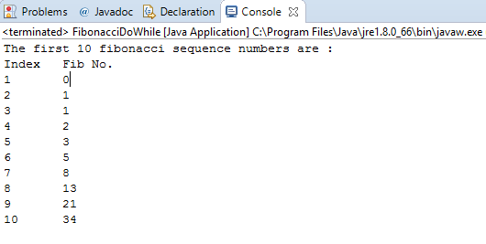

Fig 1: doWhileLoop

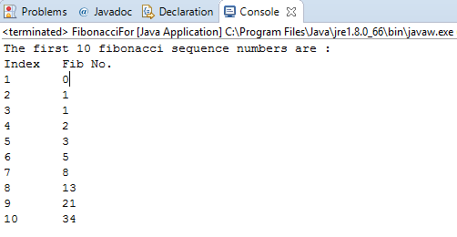

Fig 2: forLoop

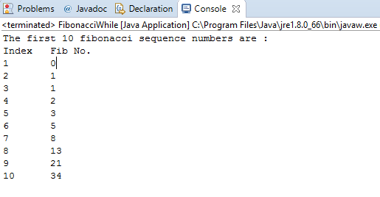

Fig 3: whileLoop